Memorandum to: FPOM Dec 06, 2012
From: Stephen Schlenker, CENWP-EC-HD
Martin Hansen, CENWP-EC-HD
Miro Zyndol, CENWP-OD-J
Subject: Low Channel Velocities at John Day North Fish ladder during Low Tailwater conditions.
Background:
Poor fish passage was noted at John Day North Fishladder in the fall, after spill ended and the tailwater elevations dropped after September 1. Project Biologist Miro Zyndol construed a theory that fish were entering the ladder, but were not progressing up the ladder from the Diffuser 2 pool. (The AWS discharge through the new fixed entrance weir was substantially higher in 2012, so “fish attraction” was assumed to be at least equal, and likely better as compared with the past years.) Our discussions led to a probable cause of delay due to low velocities between the middle of diffuser 2 to the base of the ladder. These problems should be corrected when this season’s (2) construction is completed.
EC-HD provided some initial 1-D numerical model runs to show the difference between operation at optimum 1.5 feet of entrance head and at higher heads (however, there was an error in the simulations—as the ladder flow was way too low in the simulations). Miro suggested a biological/field test to confirm his “slow velocity inside the fishway” theory, which would consist of a substantial increase of the total AWS output (higher than the normal design range for the given Tailwater level). The test was implemented on September 19 by putting all three available AWS pumps in manual control to achieve their maximum output ; that operation resulted in the entrance head (EH) being above the 2 feet ( 2.1’ to 2.4’ depending on tailrace’s elevation, September 19 through September 26. Additionally, to further increase flows inside the fishway, the depth of water over the ladder weirs was increased from the default 1.0 feet for salmon passage, to 1.3 feet, normally reserved for shad passage season (June-July) on September 20. After September 26, the AWS pumps operation was dialed back to set the entrance head below 2.0 feet and above about 1.6 feet.
A plot of the percent of total daily adult Chinook salmon passed by the North Fishladder in 2012 versus the average daily percent in 2009-2011 (compiled by Miro Zyndol) is shown in Figure 1. The data record goes from Aug 06 – Oct 31 for each year. The red solid line represents 2012, the blue dashed line represents 2009-11. The light green line represents the total daily adult salmon passed in 2012 graphed against the secondary axis over the same time period.
The graph shows the poor, post-spill performance of JDAN in 2012 in comparison to previous years, and partial improvement with the interim operations after Sept 19, 2012.
Figure 1 - Percent of Total Adult Chinook Salmon passed at North Fishladder and Total Daily Adult Chinook Count

In early October, Project biologists collected surface velocity data that showed much higher values than the EC-HD 1-D model results. However surface velocities normally will be higher than average velocities. To resolve these questions and verify/ calibrate the model, EC-HD performed flow and velocity measurements on Oct 18-19, 2012. The AWS flow measurements were also used to verify/ calibrate the relationship between entrance head and entrance discharge at low tailwater conditions.
Locations of Flow Measurements:
The general locations of AWS flow and channel velocity measurements are shown in the red ovals in Figure 2.
- Total AWS flow was measured in the AWS conduit through an existing air vent on the west side of weir 174. The entrance flow is determined by the AWS flow measurement + 113 cfs from the ladder flow (at 1.3-foot ladder head).
- Channel velocities were measured at location 2 shown in better detail in Figure 3 (yellow box). The measurement was taken 6 feet downstream of the upstream end of diffuser 2, or former (now removed) Weir 155 location. This location was most upstream location that could be safely measured by the EC-HD team.
Location of Model Data Reference Points in Upstream Order (see Figure 3 – blue boxes)
- Downstream end of diffuser 1 and approaching entrance
- Downstream end of diffuser two and upstream end of 180 degree bend
- Upstream end of Diffuser 2 or former weir 155 location (6 ft u/s of field meads location 2)
- Base of ladder or just downstream of weir 158.

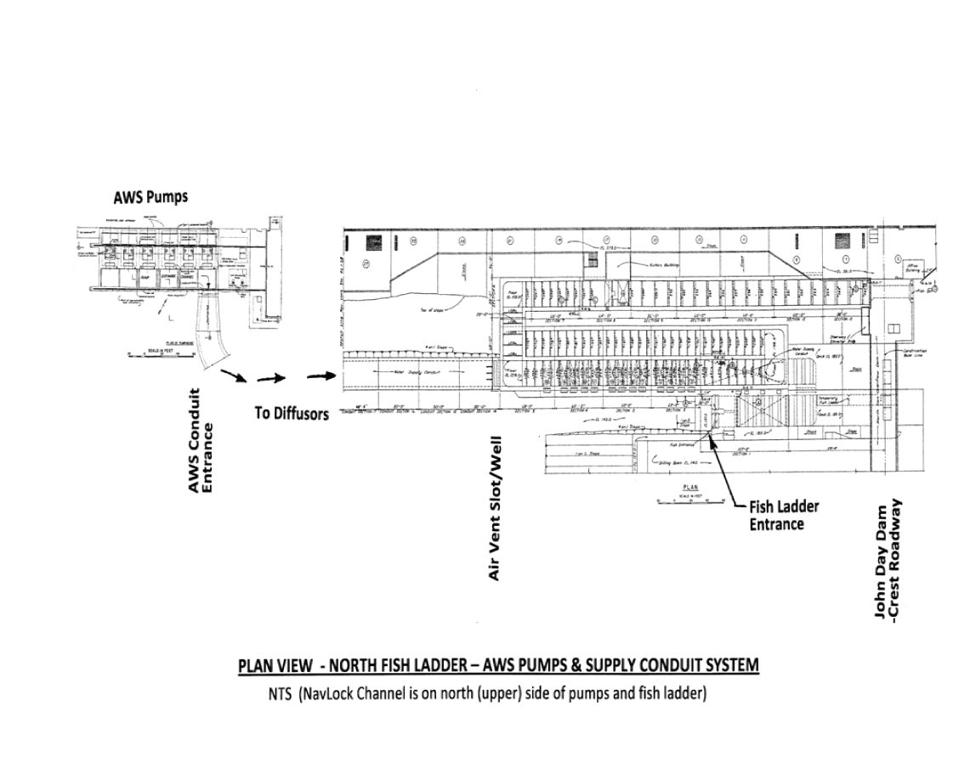
Channel Velocity Measurements
Near Wr 155
(Location 2)

AWS Discharge
Measurements
(Air Vent east of Weir 174)
Figure 2 - Plan View of John Day North Fishladder with Measurment Locations

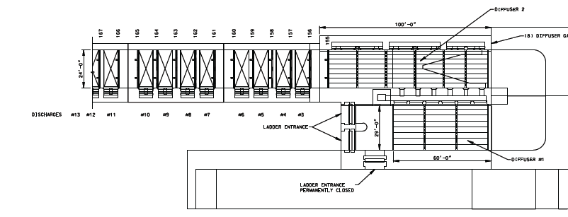
1
2
3
4
0
3
2
1
3
4
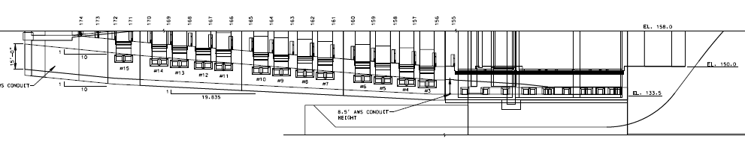Figure 3 – Location of Flow Measurement (2) and Locations of Model Data Reference Points (0, 1, 3, & 4)
Flow Conditions Measured (numbering started from initial tests in spring):
Ladder Head = 1.3 feet (113 cfs ladder flow) in all test cases below.
Pump Test 11:
Conditions under operation on initial day of site visit:
Tailwater Elevation = 159.15 feet Entrance head = 1.7 feet

Pump Test 12:
Conditions changed on 2nd day of site visit:
Tailwater Elevation = 159.15 feet Entrance head = 1.5 feet

Pump Test 13:
Conditions changed on 2nd day of site visit:
Tailwater Elevation = 159.1 feet Entrance head = 2.2 feet

Results of Flow Measurements and Comparative Model Results:
The field measurement data (yellow highlighted cells) are shown in Table 1 for the three different pump tests and entrance head conditions. The grey cells with italic font are interpolated or estimated data. The 1-D model was run for equivalent tailwater and entrance head conditions; and the data is shown in the rows following each of the field measurement rows. Direct model data are show in bold font without highlight and interpolated data are shown in the grey cells with italic font (same as with measurements). The difference between measured data and model data are shown in the rows that follow each model data row. The average differences between the three tests are shown in the bottom row. As can be seen by the average differences, the model slightly under predicts the average velocities (0.07 ft/s), but does a good job overall. The field data velocities in Pump Test 12 appear to be an aberration in comparison with the other two tests and account for the majority of the average differences in velocity between model and field data. In short the model is a reasonable, albeit slight conservative, predictor of channel velocities.
Model Data Comparing Year 1 and Year 2 Low Tailwater Operations:
The model data for this season (Year 1) operations and next year’s operations (Year 2) for different entrance head and ladder head operations at low Tailwater 159 are shown in Table 2. The following conditions were simulated:

Year 1 Year 2
1 a: entrance head = 1.5 ft, ladder head = 1.0 ft 2 a: entrance head = 1.5 ft, ladder head = 1.0 ft
1 b: entrance head = 1.8 ft, ladder head = 1.3 ft 2 b: entrance head = 1.8 ft, ladder head = 1.0 ft
1 c: entrance head = 2.2 ft, ladder head = 1.3 ft 2 c: entrance head = 1.8 ft, ladder head = 1.3 ft

Table 1 – Field Measurement Data with Comparative Model Data under Different Entrance Head Conditions
John Day North Fishladder at Low Tailwater: Field Data taken Oct 18-19, 2012 versus Model Data
 |  | Discharge Rates (cfs) |  | Velocities
Operation ( TW = 159.1 feet) |  |  |  | 1 | 2 | 3 | 4
Pump Test | Description | Entrance | Over Weir 158 | D/S end | 6' d/s of | Weir | Base of | Max | Weir 158
Pump Test | Entrance head and Ladder head | Entrance | Over Weir 158 | of Diff 2 | Weir 155 | 155 | Ladder | Diffuser | Orifice | Weir
11 | Entrance head = 1.7', Ladder Hd = 1.3'
 | Field Measurement (Oct 18, 2012) | 1040 | 122 | 2.40 | 0.80 | 0.71 | 0.61 | 0.23 | 1.2 | 2.3
 | Model | 1037 | 121 | 2.40 | 0.80 | 0.71 | 0.61 | 0.23 | 1.2 | 2.3
 | Difference Observed - Model | 3 | 0 | 0.0 | 0.0 | 0.0 | 0.0 | 0.0 | 0.0 | 0.0
12 | Entrance Head = 1.5', Ladder head = 1.3
 | Field Measurement (Oct 19, 2012) | 954 | 137 | 2.32 | 0.88 | 0.77 | 0.67 | 0.22 | 1.5 | 2.9
 | Model | 959 | 113 | 2.25 | 0.72 | 0.64 | 0.55 | 0.21 | 1.3 | 2.4
 | Difference Observed - Model | -5 | 24 | 0.1 | 0.2 | 0.1 | 0.1 | 0.0 | 0.3 | 0.5
13 | Entrance Head = 2.2', Ladder head = 1.3
 | Field Measurement (Oct 19, 2012) | 1225 | 169 | 2.78 | 1.05 | 0.94 | 0.82 | 0.26 | 1.0 | 2.1
 | Model | 1223 | 162 | 2.76 | 1.00 | 0.90 | 0.79 | 0.26 | 0.9 | 2.0
 | Difference Observed - Model | 2 | 7 | 0.0 | 0.0 | 0.0 | 0.0 | 0.0 | 0.0 | 0.1
Average Differences (Meas. - model) |  | 0 | 11 | 0.0 | 0.07 |  | 0.05 | 0.0 | 0.1 | 0.2
XX | Field Measurement
XX | Interpolated data
XX | Model Data

Table 2 – Comparative 1-D Model Simulations for Different Year 1 and Year 2 Low Tailwater Operations

Referring to Table 2, operation 1 a (EH = 1.5’, LH = 1.0 ‘) for Year 1 has the lowest velocity at the base of the ladder (0.5 ft/s). The velocities were raised to 0.8 ft/s under interim operation 1c (EH= 2.2 ‘, LH = 1.3’), hence improvement in fish passage. The final interim operation 1 b (EH=1.8’, LH =1.3’), the base of the ladder velocity falls between the two others. This appears to explain the improvement in fish passage under the interim operations.

In Year 2 operations (second tier of rows in Table 2), the default operation 2a (EC=1.5’, LH=1.0’) provides superior velocities (1.2 ft/s) at the base of the ladder than any of the interim operations in Year 1. The reason for the improvements in velocity is due to construction improvements to occur this in-water work period:
- Lower stove pipe weir 2.5 feet to improve hydraulic efficiency into the ladder diffusers 3- 13.
- Operate new sluice gates to restrict flow into large diffuser 2 and force more flow into ladder diffusers 3-13. At Tailwater 159, the recommended operation is for 2 sluice gates open and 6 gates closed. (At high tailwater levels there will be mostly open.)
At low tailwater, higher entrance head operations (2b and 2c, EH= 1.8’) may be considered next season to both boost entrance attraction at low tailwater and further enhance velocities at the base of the ladder. The difference between operations with varying ladder head (1 or 1.3 ft) appears to be insignificant in this case and the normal 1.0 foot ladder head should be applied unless needed for shad passage.

Comparison of Measured Surface Velocities and Average Velocities in Ladder Channel:
The field measured velocities in the Ladder Channel at Location 2 (near former Weir 155) varied considerably with depth. In particular, the surface velocities (measured 1 foot below water surface) were on average 1.7 times higher than the average velocities over the full depth. The velocities were averaged across the channel for each of the three depths of measurement. The average velocities for each depth versus percent of channel depth are shown in for each of the three pumps tests. The average velocities (vertical lines represent average over full depth) for each pump test are also presented in this figure for context.
The ratio of surface velocity to average velocity should drop under higher tailwater conditions and will rise for lower tailwater conditions. This is due the fact that as the Tailwater rises, the most downstream weir (Weir 158 now) will block a lower percentage of the flow area at the weir. The surface to average velocity ratio should also drop in general moving in the downstream direction due to more flow mixing between the flow strata with distance from the most downstream weir.
Figure 4 – Velocity versus Percent of Flow Depth Measured in the Field for Each Pump Test

Summary Conclusions:
- The Interim Operations (increasing entrance head above criteria (2 feet) or at least above optimum 1.5 foot entrance head) partially improved fish passage conditions this fall.
- The field measurements confirmed that average channel velocities were well below channel NMFS criteria (1.5 ft/s minimum).
- In comparison with the field data, the 1-D model provides a reasonably accurate simulation of the actual average velocities and entrance head conditions in the John Day North Fishladder.
- At low tailwater, the surface velocities are much faster than the average velocity (average ratio = 1.7) in the fishladder channel at the upstream end of diffuser 2.
- The model data indicates that the low velocity problem should be largely resolved with the final construction improvements and Diffuser 2 sluice gate operations.

CC: Tammy Mackey, CENWP-OD-TF
Sean Tackley, CENWP-PM-E
Natalie Richards, PM
Marie Phillips, Acting Chief, CENWP-EC-HD

